**Update on Stature automated testing**

* For purpose of running test case without preparing any user data with specific role permissions, we have to update our test method.

**1. Prepare test data**

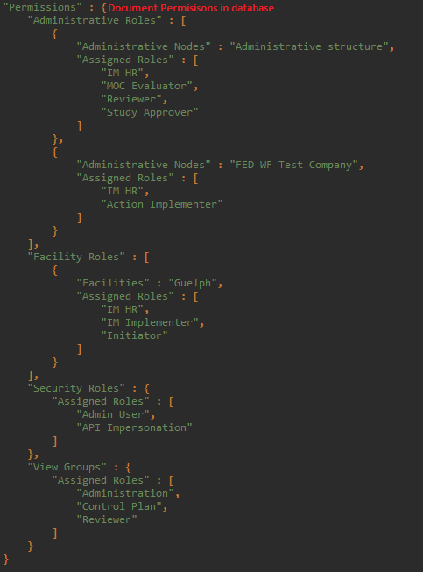You do not need to create a user before running your test case, but you must define roles for user running the test. User permissions is shown as a Json object and save on your database following exactly structure, please see my example below:

*Figure 1-1. Json object structure of Role Permissions*

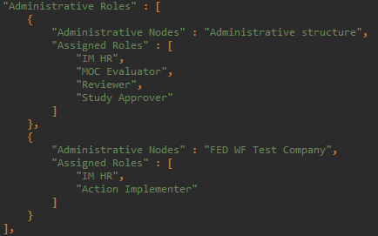***a. Administrative Roles***

*Figure 1-2. Administrative Roles*

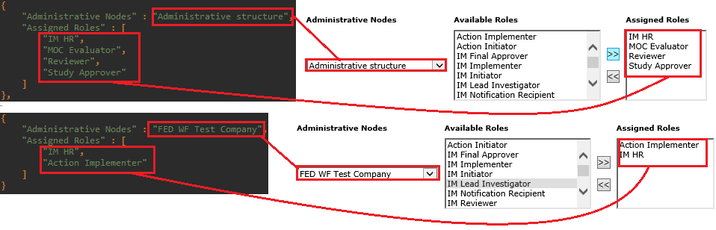- Administrative Roles is a list of Json objects, each object contains 2 values of “Administrative Node” and “Assigned Roles”:

*Figure 1-3. Mapping between Json Administrative Roles and Web app*

***b. Facility Roles***

- Facility Roles has the same structure as Administrative Roles.

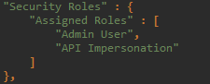***c. Security Roles***

*Figure 1-4. Security Roles*

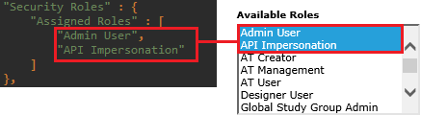- Security Roles is a Json object contains list roles that you want to assign:

*Figure 1-5. Mapping between Json Security Roles and Web app*

***d. View Groups***

- View Groups has the same structure as Security Roles.

**2. Implementation**

***- Initialize web driver:*** + Start your automation test and login with admin account (user name and password in “testclass-data”).

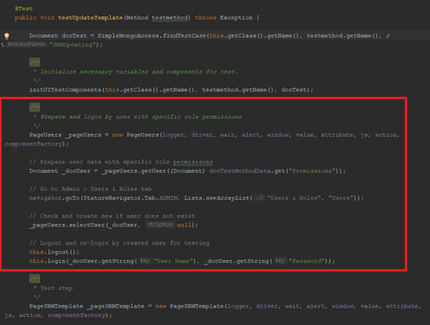***- Get user data with specific roles:***

*Figure 2-1. New code adding in test method*

+ Add following code into your test method for auto generating and login by user with permissions using in test case

*/**  
 * Prepare and login by user with specific role permissions  
 */*PageUsers _pageUsers = new PageUsers(logger, driver, wait, alert, window, value, attribute, js, action, componentFactory);  
  
// Prepare user data with specific role permisisons  
Document _docUser = _pageUsers.getUser((Document) docTestMethodData.get("Permissions"));  
  
// Go to Admin > Users & Roles tab  
navigator.goTo(StatureNavigator.Tab.*ADMIN*, Lists.*newArrayList*("Users & Roles", "Users"));  
  
// Check and create new if user does not exist  
_pageUsers.selectUser(_docUser, null);  
  
// Logout and re-login by created user for testing  
this.logout();  
this.login(_docUser.getString("User Name"), _docUser.getString("Password"));

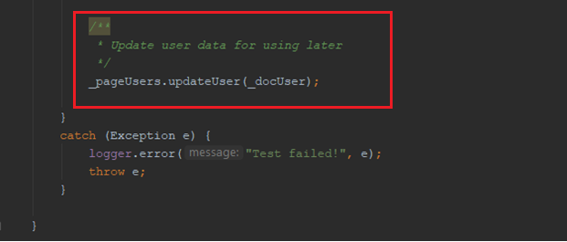- Leave user free and update it into database for using later:

*Figure 2-2. New code adding in test method*

+ After implemented your code, add following code at the end of test method for updating user data into database

*/**  
 * Update user data for using later  
 */*_pageUsers.updateUser(_docUser);

***Note:***

- If you don’t need to assign any session of Role Permissions (Administrative, Facility, Security or View Groups), you don’t need to input it into document “Permissions”.

- Put your desired permissions from session 1 into function “getUser(Document desiredPermissions)”. In the example code above, because I put document “Permissions” into my “testmethod-data” in database, so the function will be:

*Figure 2-3.Document “Permissions” from database*

- You can put “User Name”, “First Name” and “Last Name” fields into document “Permission” to specialize those user information.